This what I have from what’s been done so far. I made some modifications for conformity, but feel free to change it up if I have misinterpreted your diagram.

Link, code, and image below...

-- Cody

-

http://plantuml.com:80/plantuml/png/bLFRYjim47tNLmn-sJRWfNujfT0uALtePM7RxkEYs1DRNLioajnDQFll7LrYowPGrf1uvfoPCvhHk1KrGYLqrI5hdOtzOC_GesrLRLBeAB0ZH2gBa7r5tiET-ebQDFBAGDbnOs0dUADvdm4tyBbWbGVlyV2mvGRhXvlTFcBV3Efelgjx8QEzFs4rMg4k_WuFOzC8sKI_LFqWEkuZs1GCctp1pCIRttcUYBYg3eEio49PZv2Nvs_dul0Qz2WDeoUH9RJo7fQgnXSlLzoNmm-iB5WysVSKisBDMLf-Abki7YcJfQLYua58hiy-DMNHsxZrh4kTkfbJ4_6FmjX5Y46xrSWVRvMGrkKlRWCKpIVRP72hbPDYB1g1AAwlYrTPkAom2SzP5BPIepA-FVSt8P-uv0qwo2o9Ez_K1z6q7Vsikxu5VrEZjE9u3eTBPAZfaZgstgEEbzI-5lQVn0uxd7BeWR1nLSljBmRKfZ4KxUSBC0xVwIkWG81QFSd9CGEDEi1Upfb_Bb9HmgcvBN4lGPZb_K2svhv7bsdeamgR71MfmrdcgFJOEv4X3FS_HvBuv298EpbNYj1Iz-XtOwwHI5EOAoPvZ_GYPTInudJY63rhcRKikpGFUPqhFrGQ-OO5osFBaiGMR8tvED--JrvibuV_0W00

@startuml

hide circle

hide empty methods

hide empty fields

note "Team Soverign's Class Diagram" as N1

class Web_Based_IDE

class User

class Admin

class Execution

class Debugging

class Compilation

Execution *- Compilation

Execution <|-- Debugging

User <|- "1"Admin

User "1"--> Execution : runs

Compilation : compileCode()

Compilation : Object textFile

Compilation : syntaxCheck()

Execution : Object binaryFile

Execution : executeBinary()

Debugging : Object syntaxCheckList

Debugging : setBreakPoint()

Web_Based_IDE o-- "*" Project

Project o-- "1..10" User

hide circle

hide empty methods

hide empty fields

Project o-- "*" File

File o-- "*" ManageFiles

File o-- "*" SyntaxHighlighting

File o-- "*" IdentifyUser

ManageFiles : CreateFile()

ManageFiles : EditFile()

ManageFiles : DeleteFile()

class chat{

messageList

upVote()

downVote()

speak()

delete()

}

class message{

text

timestamp

rating

designation

speaker

}

class forum{

projectList

upVote()

downVote()

newListing()

deleteListing()

comment()

}

class projectListing{

name

ownerList

rating

project

comments

comment()

}

message -d-o chat : *

chat -d-o projectListing : 1

projectListing -d-o forum : *

Project o-- forum

@enduml

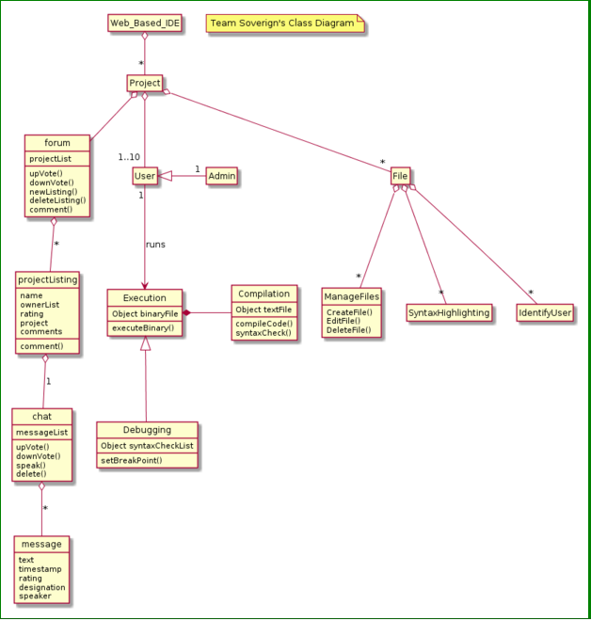

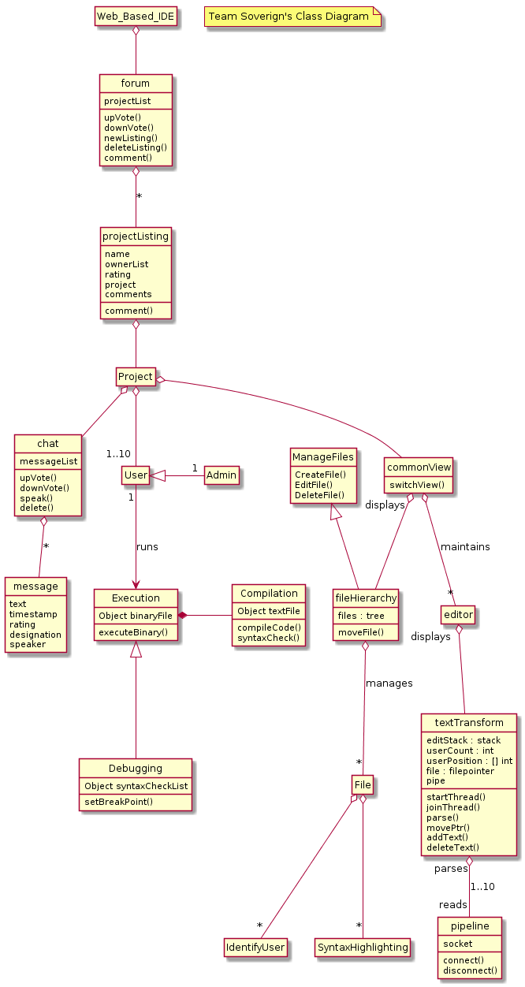  
@startuml

hide circle

hide empty methods

hide empty fields

note "Team Soverign's Class Diagram" as N1

class commonView {

switchView()

}

class editor {

}

class textTransform {

editStack : stack

userCount : int

userPosition : [] int

file : filepointer

pipe

startThread()

joinThread()

parse()

movePtr()

addText()

deleteText()

}

class pipeline {

socket

connect()

disconnect()

}

class fileHierarchy {

files : tree

moveFile()

}

class Web_Based_IDE

class User

class Admin

class Execution

class Debugging

class Compilation

hide circle

hide empty methods

hide empty fields

class chat{

messageList

upVote()

downVote()

speak()

delete()

}

class message{

text

timestamp

rating

designation

speaker

}

class forum{

projectList

upVote()

downVote()

newListing()

deleteListing()

comment()

}

class projectListing{

name

ownerList

rating

project

comments

comment()

}

message -d-o chat : *

Project o-d- chat

projectListing -d-o forum : *

Web_Based_IDE o-d- forum

ManageFiles <|-d- fileHierarchy

File o-- "*" SyntaxHighlighting

File o-- "*" IdentifyUser

ManageFiles : CreateFile()

ManageFiles : EditFile()

ManageFiles : DeleteFile()

Execution *- Compilation

Execution <|-- Debugging

User <|- "1"Admin

User "1"--> Execution : runs

Compilation : compileCode()

Compilation : Object textFile

Compilation : syntaxCheck()

Execution : Object binaryFile

Execution : executeBinary()

Debugging : Object syntaxCheckList

Debugging : setBreakPoint()

projectListing o-d- Project

Project o-- "1..10" User

Project o-d- commonView

commonView o-d- "*" editor : maintains

commonView "displays" o-d- fileHierarchy

fileHierarchy o-d- "*" File : manages

editor "displays" o-- textTransform

textTransform "parses" o-- "reads" pipeline : 1..10

@enduml